Exam Preparation
Test your tasks in the Judge system: https://judge.softuni.org/Contests/4455/Exam-Preparation-II

Magic Numbers
Write a program that:
- Reads an integer number N from the console, always greater than or equal to 1
- Print all magic numbers in range [1; N] - separated by single space
- The number is magic when:
  - All of its digits are prime numbers
  - Sum of all digits is divisible by 2
- If the are no such numbers print "no"

Example
Input | Output | Comments
25 | 2 22 | We have to check numbers in range [1; 25]  Magic numbers in this range are 2 and 22.
100 | 2 22 33 35 37 53 55 57 73 75 77

Min / Max Values
Write a program that:
- Reads an array of integer numbers from the first line of the console, separated by single space
- Read an integer number N from the second line of the console
- Find max number in the first N elements in the given array
- Find min number in the first N elements in the given array
- Print max number and min number, each on separate line

Example
Input | Output | Comments
3 42 61 7 8 9 10 23  4 | 61  3 | First 4 numbers in the array are: 3 42 61 7  Max number is: 61  Min number is: 3
12 34 98 42 65 12  3 | 98  12 | First 3 numbers in the array are: 12 34 98  Max number is: 98  Min number is: 12

Unit Test Method: Pascal Triangle
Test a given method which takes in an integer n and prints that number of rows from the pascal triangle.
The method is found in the PascalTriangle.cs file:
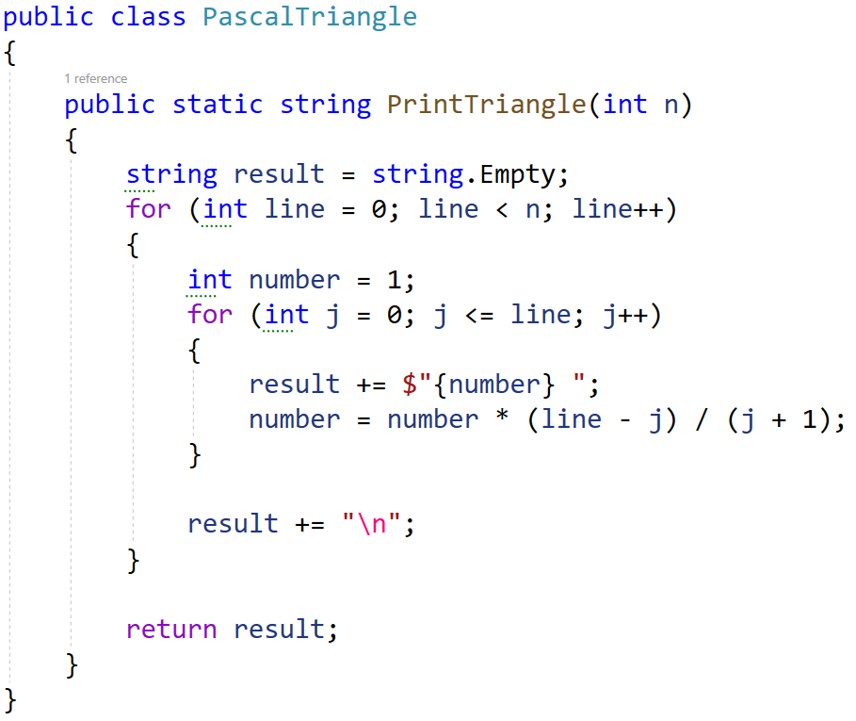
You are given a test file PascalTriangleTests.cs containing 5 empty test cases. Implement all the cases:
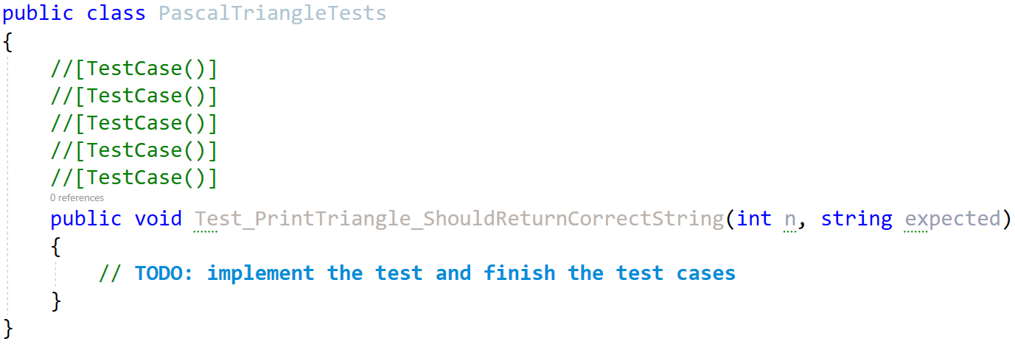
When you are ready make sure your tests run:
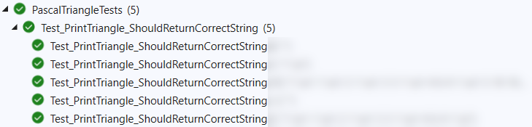
IMPORTANT: DO NOT REMOVE OR CHANGE ANY NAMESPACES AND USINGS.

Unit Test Array: Longest Increasing Subsequence
Test a given method which takes in an integer array and finds the longest increasing subsequence (LIS).
The method is found in the LongestIncreasingSubsequence.cs file:
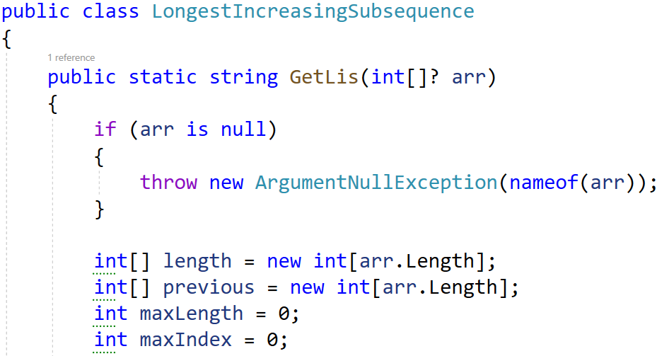
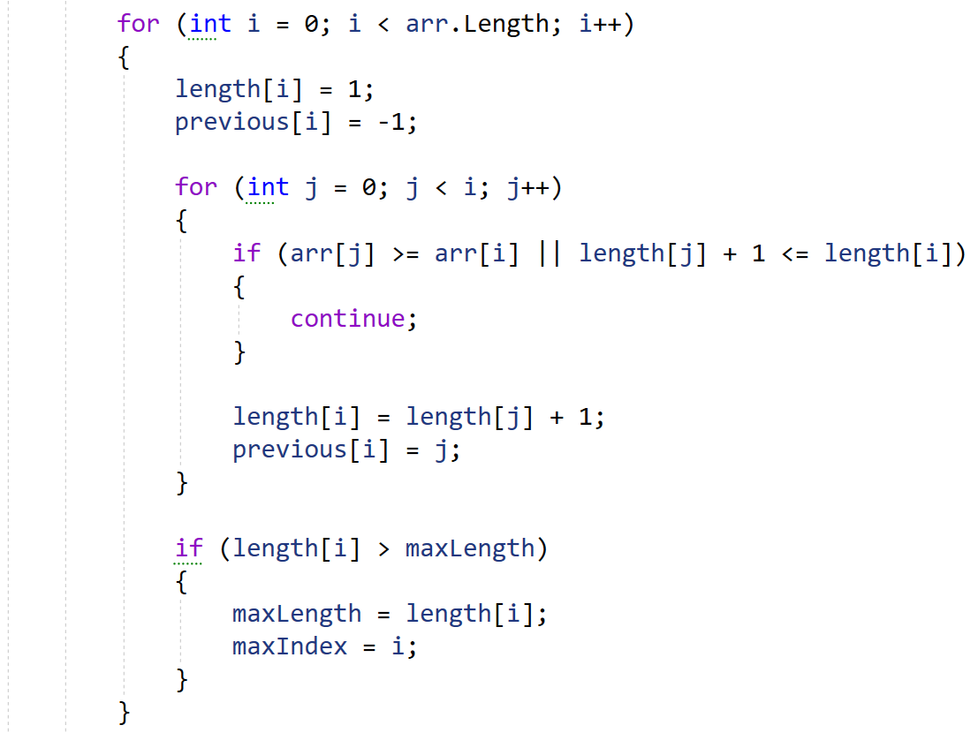
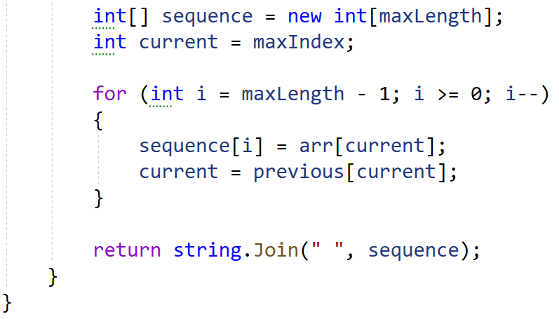
You are given a test file LongestIncreasingSubsequenceTests.cs containing 5 empty tests. Implement all the unit tests: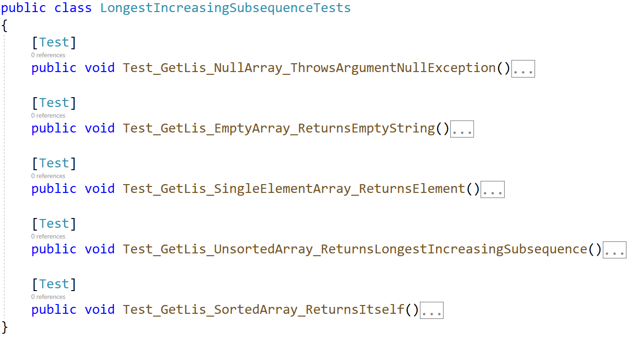
When you are ready make sure your tests run:
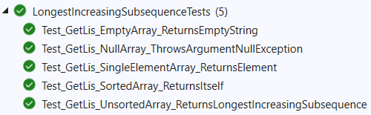
IMPORTANT: DO NOT REMOVE OR CHANGE ANY NAMESPACES AND USINGS.

